
8 January 2024

North Yarra Main Sewer Rehabilitation
Section B Sewer Cleaning and Investigative Works

What are we doing?
We are ready to commence cleaning and investigative works of the North Yarra Main Sewer (NYM) Section B, NYM119 to NYM112, from 15 January 2024*. We will work from maintenance hole to maintenance hole, using high-pressure cleaning equipment and a sucker truck to clean the sewer pipe. Once cleaned, we will run a camera train along the pipe to get CCTV footage of the condition of the sewer.

Location of Works- Section B

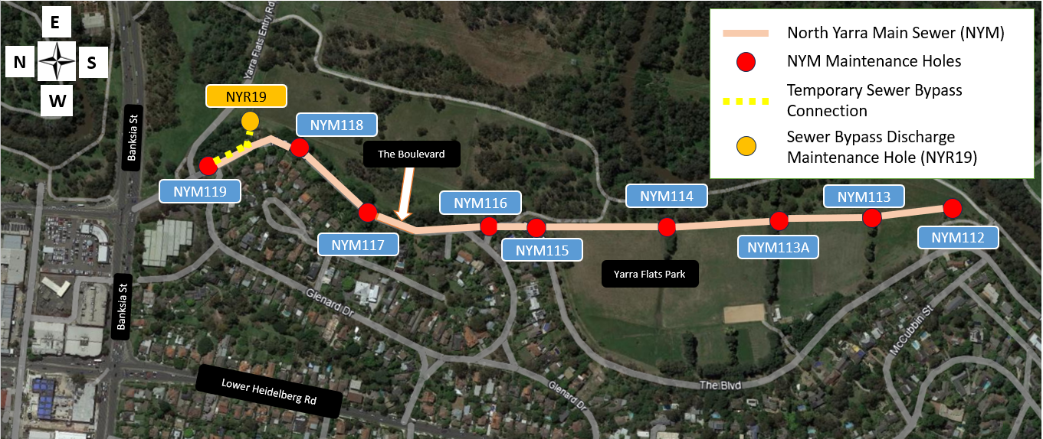

Sewer Bypass set-up

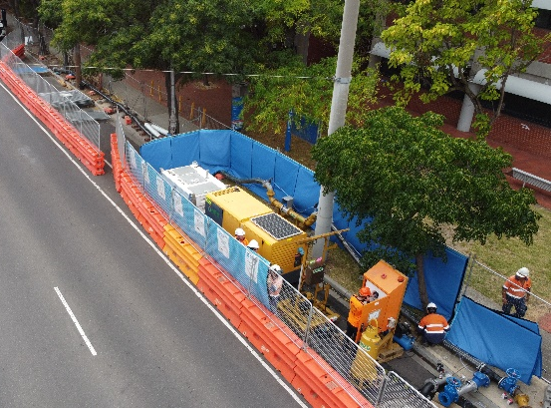
While cleaning and relining in Section B, we will divert the sewer flows into the North Yarra Reliever Sewer (NYR), which runs parallel to the NYM sewer. A 150mm pipe will be installed above ground along The Boulevard and into Yarra Flats Park to discharge sewer flows into the maintenance hole at NYR19.

The installation of the bypass will begin on 8 January 2024*, and we expect to have the system in place and commissioned within one week.

This bypass setup will be in place until all relining works in Section B are complete. This is expected to be

mid-2024.
Example of sewer bypass pumping system

What to expect?
- The high-pressure cleaning truck and sucker truck will be set up at maintenance holes. These trucks generate loud noise and can be compared to a street sweeper truck.
- Reduced car parking along The Boulevard to allow room for bypass system and work equipment.
- A camera van will be set up at alternative maintenance holes to the cleaning truck. A CCTV camera train will be sent into the sewer to access the condition of the existing sewer pipe.
- Traffic management will be present to assist motorists, cyclists, and pedestrians around our temporary work sites. Please allow extra travel time.
- Odour will be present when opening and accessing the maintenance holes. We recommend closing doors and windows while we are working close to your property.
- Bright lights will be used during night works. Where possible, lights will be directed away from neighbouring property windows.
- Noise from generator and pumps when the bypass system is running. We will implement noise reducing methods to minimise disruption to the community.

Working hours

Works will be scheduled from 7am to 6pm*, Monday to Friday. On occasions we may need to undertake night works and weekend works. We will notify you in advance if these works are required.

*These times and dates and are indicative and subject to change with no prior notice due to weather conditions and fluctuating sewer flows.
There will be no interruption to your water or sewerage services during our works. If you experience any issues with your sewerage service, please contact Yarra Valley Water on
1300 304 688.

